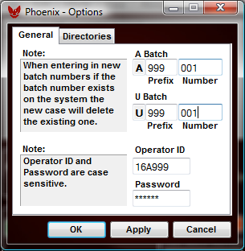
Prefix – Each Phoenix user gets a unique 3 digit number to prefix their batches.

Number – Can be left at 001 and will increment automatically with each new case.

Operator ID – Unique FAMIS operator ID for each Phoenix user.

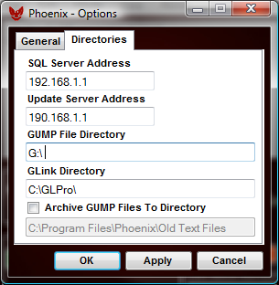
SQL Server Address – The IP Address of your SQL server.

Update Server Address – The IP Address of your update server, in this case the same as your SQL server address.

GUMP File Directory – The mapped network drive on the local machine to the folder where GUMP will be sending the text files.

GLink Directory – Can be left at the default C:\GLPro unless you custom installed GLink to a different directory.

